Task-2

1.Create a file with .txt extension (/home/demo.txt). Change the permission set of that file, so that any user can read it, group can read/write & owner can read/write/execute it.

Step 1:

Create the File: **sudo touch /home/demo.txt**

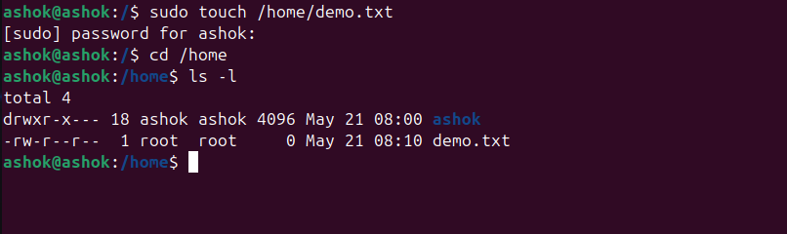

Step 2:

Set the Correct Permissions: **sudo chmod 764 /home/demo.txt , ls -l /home/demo.txt**

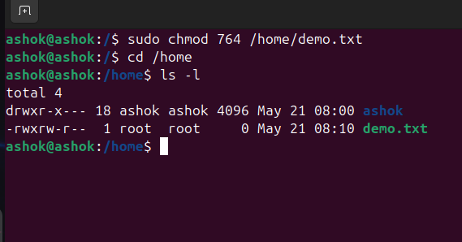

Step 3:

Change Owner or Group: **sudo chown username:groupname /home/demo.txt**

